**Cuizine:**

Falooda

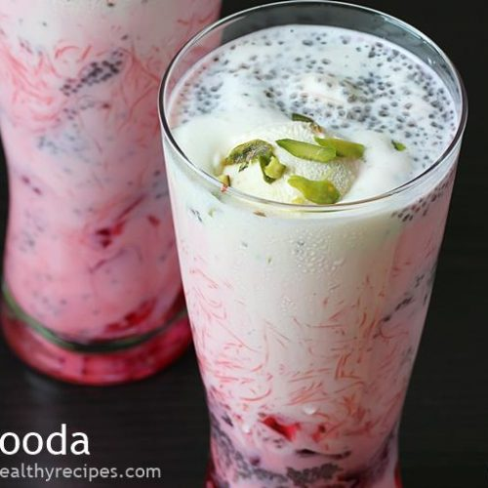

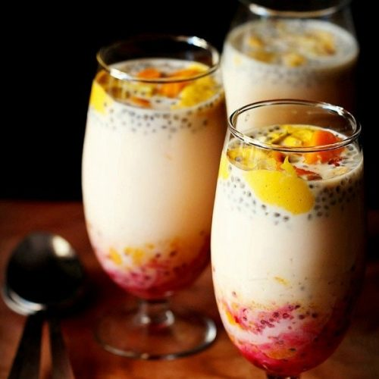

**Falooda** (also **Faluda, Faloodah**) is a cold dessert with origins in the Indian subcontinent. Traditionally it is made from mixing rose syrup, vermicelli, sweet basil (**sabza/takmaria**) seeds with milk, often served with ice cream. The vermicelli used for preparing falooda is made from wheat, arrowroot, cornstarch, or sago. Falooda is not only a drink but can be a meal in itself. Some ingredients like soaked basil seeds have a cooling effect on the body. Falooda is also often served with various nuts.